**SANMARG SHIKSHAN SANSTHA’S**

**LATE VASANTDDADA POLYTECHNIC, NAGPUR**

**Session: 2012-2013**

**Information Technology (3E)**



**SYNOPSIS ON**

**virtual piano in V.B.**

**Submitted By: By:**

**Shreyas p. Kawale**

CONTENTS

* INTRODUCTION
* MODULE
* DESCRIPTION OF SOFTWARE
* HARDWARE REQUIREMENT
* SOFTWARE REQUIREMENT
* REFERENCE

**INTRODUCTION**

The title of my project is **“virtual piano in V.B.”**

**“virtual piano”** is not use for any professional use it is just for fun

In the **“virtual piano”** when we press Alt+ a, s, d, f, g, h, j, k, w, e, r, y, u, I than it makes sound of note we can’t chose any instruments sound

This is the easiest way I made it

My main motto was is to make the platform where we can make fun for us for free

**I try all of them:-**

[vb]Private Const SND_APPLICATION = &H80         '  look for application specific association  
Private Const SND_ALIAS = &H10000     '  name is a WIN.INI [sounds] entry  
Private Const SND_ALIAS_ID = &H110000    '  name is a WIN.INI [sounds] entry identifier  
Private Const SND_ASYNC = &H1         '  play asynchronously  
Private Const SND_FILENAME = &H20000     '  name is a file name  
Private Const SND_LOOP = &H8         '  loop the sound until next sndPlaySound  
Private Const SND_MEMORY = &H4         '  lpszSoundName points to a memory file  
Private Const SND_NODEFAULT = &H2         '  silence not default, if sound not found  
Private Const SND_NOSTOP = &H10        '  don't stop any currently playing sound  
Private Const SND_NOWAIT = &H2000      '  don't wait if the driver is busy  
Private Const SND_PURGE = &H40               '  purge non-static events for task  
Private Const SND_RESOURCE = &H40004     '  name is a resource name or atom  
Private Const SND_SYNC = &H0         '  play synchronously (default)  
Private Declare Function PlaySound Lib "winmm.dll" Alias "PlaySoundA" (ByVal lpszName As String, ByVal hModule As Long, ByVal dwFlags As Long) As Long  
Private Sub Form_Load()

**But doesn’t work any of them.**

Than I try PlaySound Lib "winmm.dll" file

Than it works

MODULE

Step1:- In Microsoft Visual Basic 6.0

Step2:- Add a module in my project (In the menu choose Project -> Add Module, Then click Open)

Step3:- Insert this code to the module :

“Declare Function sndPlaySound Lib "winmm.dll" Alias "sndPlaySoundA" _

(ByVal lpszSoundName As String, ByVal uFlags As Long) As Long”

Step4:- Insert this code to your form:

**“**sndPlaySound "c:\virtual piano By Shreyas\background.wav", 1 **“**

Step 5:- inserted 14 command button and set blue color to buttons W,E,R,Y,U,I like that

STEP6:-create shortcut to website

Step7:- assign the sound to key first make note

CODEING

Step1:- In Microsoft Visual Basic 6.0 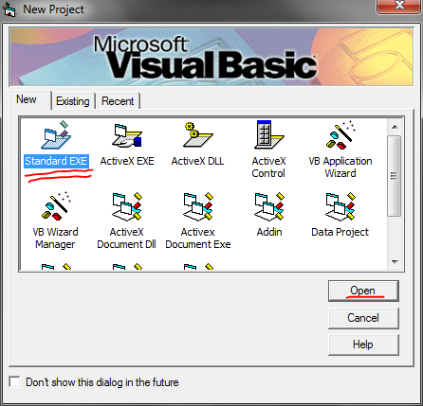

Step2:- Add a module in my project (In the menu choose Project -> Add Module, Then click Open)

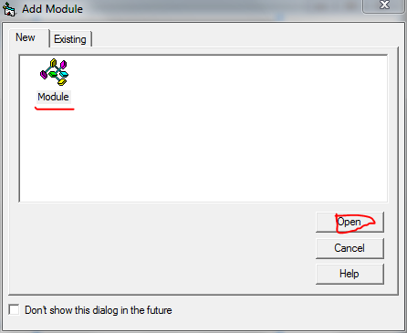

Step3:- Insert this code to the module :

“Declare Function sndPlaySound Lib "winmm.dll" Alias "sndPlaySoundA" _

(ByVal lpszSoundName As String, ByVal uFlags As Long) As Long”

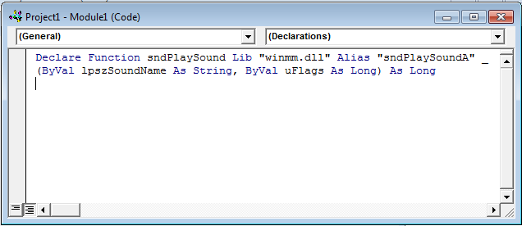

Step4:- Insert this code to your form:

**“**sndPlaySound "c:\virtual piano By Shreyas\background.wav", 1 **“**

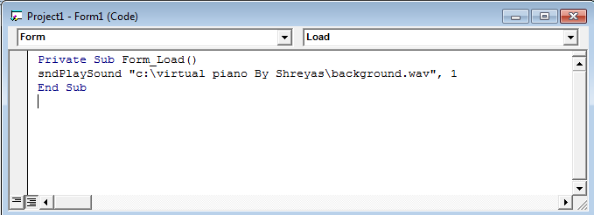

Step 5:- inserted 14 command button and set blue color to buttons W,E,R,Y,U,I like that

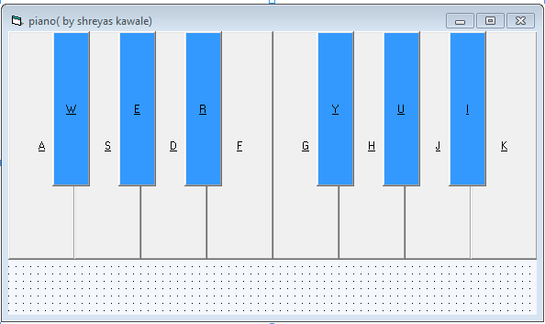

STEP6:-create shortcut to website

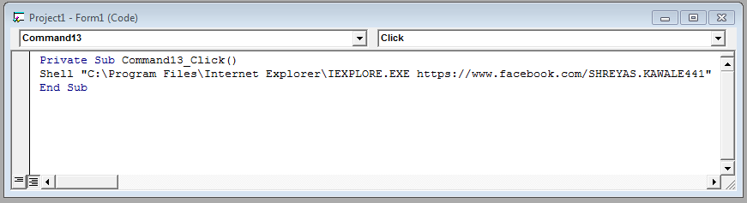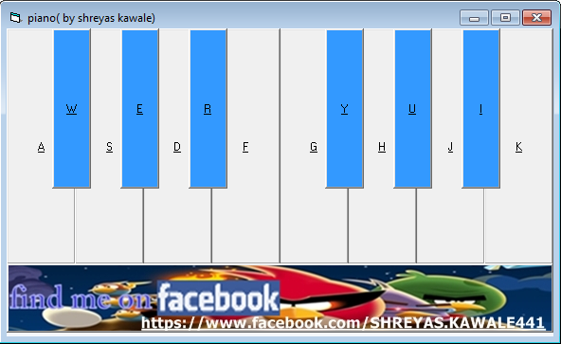

Step7:- assign the sound to key first make note

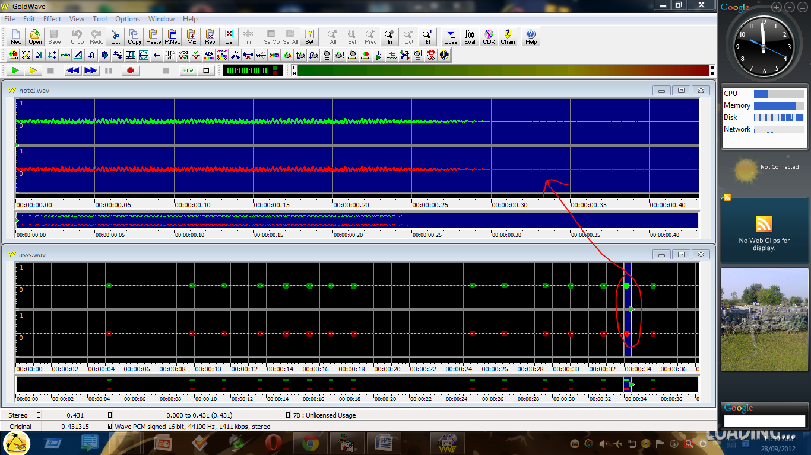

**Description of software**

The application should run on a window xp /2000 operating system. Since the application no needs a database to store any motel but it need to the extra music notes and extraction package. I was used the software named as “zip2exe” to make the package of it

**Hardware requirement:**

1. **Hard disk 20 GB OR above**
2. **Pentium4 OR above system**

**Software requirement:**

1. **Windows Xp OR above**
2. **Microsoft Visual Basic 6.0 OR above**

REFERENCE

**Link Name: Address:**

1. **Techradar** [**http://www.techradar.com/**](http://www.techradar.com/)
2. **Ranker** [**http://www.ranker.com/list-of-os/**](http://www.ranker.com/list-of-os/)
3. **Webproworld** [**http://www.webproworld.com/webmaster-forum/**](http://www.webproworld.com/webmaster-forum/)
4. **Cplusplus** [**http://www.cplusplus.com/**](http://www.cplusplus.com/)
5. **Selfseo** [**http://www.selfseo.com/**](http://www.selfseo.com/)
6. **Engineeringppt** [**http://engineeringppt.blogspot.in/**](http://engineeringppt.blogspot.in/)
7. **Frihost** [**http://www.frihost.com/**](http://www.frihost.com/)